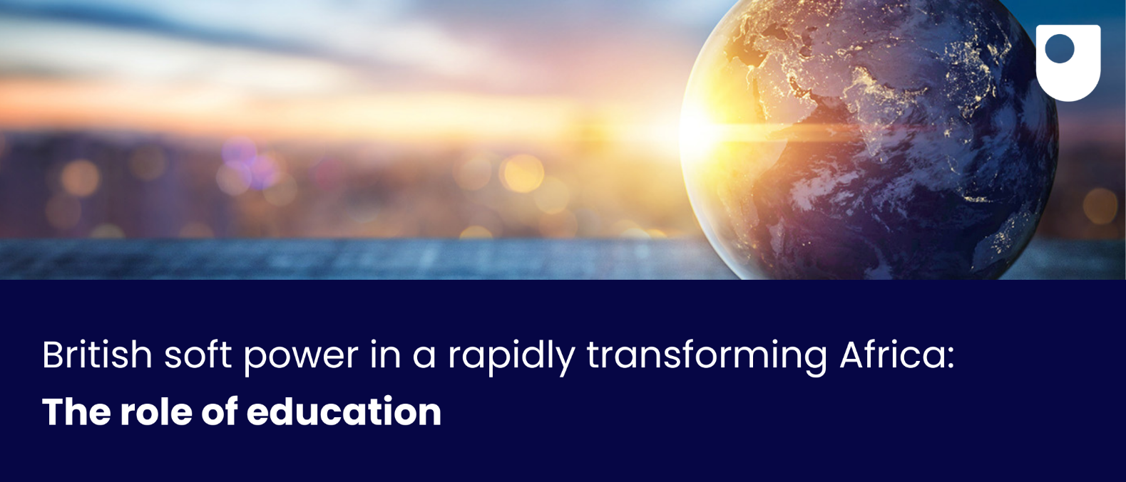

**Key Personnel**: Parvati Raghuram and Craig Walker (Open University) and Manu Lekunze (University of Aberdeen)   
Contact**:** DEPA@open.ac.uk

**2023 marked a significant turning point in political allegiances of several African countries. For instance, coups in Burkina Faso, Mali and Niger were indicative of a shift away from colonial alliances between these countries and France and even, increasingly the US. France’s footprint and authority is diminishing and even the US is losing ground. Moreover, political changes in the US may lead to a more domestic-driven policy agenda in coming years, seeing the country turning away from Africa.**

At the same time, Russia and China are playing an increasingly important role in parts of Africa and are gaining legitimacy and authority. In this context, what is the role of the UK in the geopolitics of Africa?

Findings from the **Decolonising Education for Peace in Africa (DEPA)** project funded by the Arts and Humanities Council (UKRI) suggest that the UK can play an important role in this shifting political landscape through strengthening its education portfolio in Africa. Africa has a large and growing young population who will form half of the working age population in the continent by 2050. Many countries in Africa already follow educational systems influenced by the British curriculum and examination system.

**Our research shows:**

* The educational materials in many countries are outdated and inappropriate for a changing continent.
* Moreover, conflict and its causes are not being directly addressed through education at present.
* It is possible to incorporate education for peace in the curriculum through citizenship teaching, and in many other subjects.
* This can be done through improving materials and pedagogies and there is a real demand for such educational resoources and workshops
* These can be provided as a tool to help the government to set the agenda for teachers and teaching inspectors.

**As a result, the DEPA team advocates for:**

* The institutionalisation of education for peace as a policy on the continent.
* Provision of better citizenship education materials that can be adapted to local contexts.
* Use of student-centred pedagogies that facilitate critical thinking and development of 21st century skills.
* Embedding education for peace in parts of the curriculum, that address other important global challenges, such as climate change.

This policy initiative is particularly timely, as 2024 has been declared the African Union’s (AU) Year of Education. The DEPA team presented their findings and policy advice to the African Union in a workshop organised by their Peace and Security Council. The team members have also discussed our findings with COMESA, the economic network of 13 East and Southern African countries. They are all interested in deepening the relationship between UK researchers in DEPA and their policy makers.

Although the DEPA team has made inroads into these policy circles, **the UK government can**:

* Help to amplify our work through advocacy, and
* Facilitate networking events that bring the stakeholders together.

***Open Societal Challenges****: The OU’s Open Societal Challenges Programme aims to tackle some of the most important societal challenges of our time through excellent impact-driven research by OU academics to transform lives and drive societal change. Read more:*[*societal-challenges.open.ac.uk/*](https://societal-challenges.open.ac.uk/)