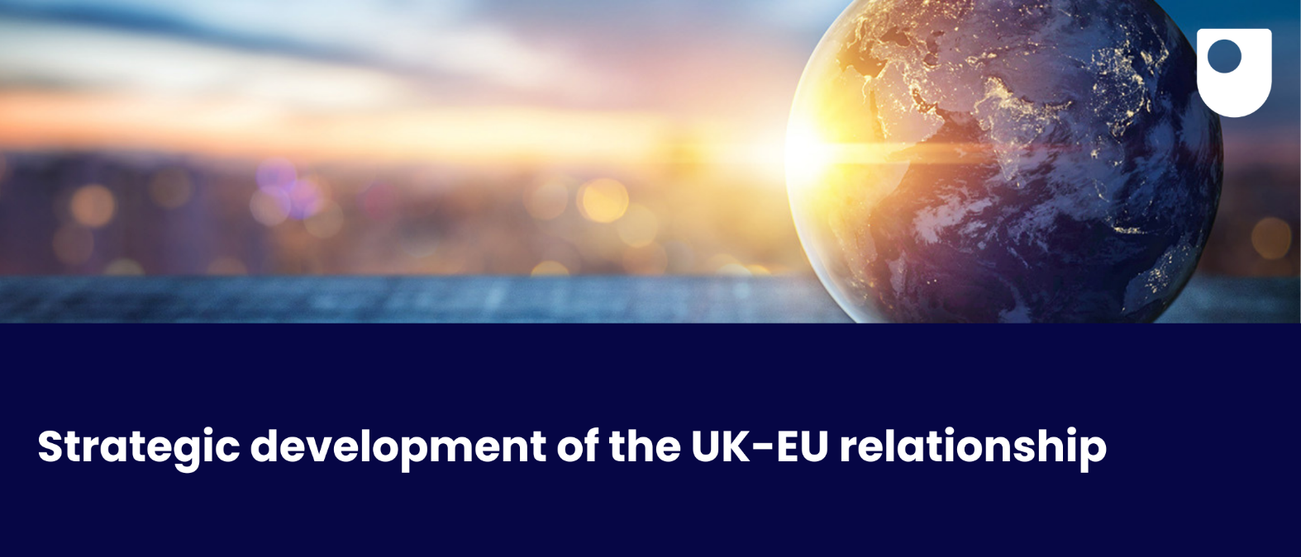

**Relations between the UK and the European Union are still in a state of flux. The Trade & Cooperation Agreement (TCA) establishes a framework for interaction, but there is still a lack of a shared vision for future relations.**

Contact: Simon Usherwood simon.usherwood@open.ac.uk

* + While the experience of the Brexit negotiations still shapes attitudes, there is scope for pursuing closer cooperation that does not compromise either side’s core interests. However, this will rely on systematic engagement with citizens’ views and concerns.
  + Such engagement is both good in itself – for democratic purposes – and good for moving to a proactive model of relations, with resilient and adaptable systems that can cope with the requirements of a dynamic and multi-faceted partnership.
  + High levels of trust are a fundamental prerequisite for stable relations, so increasing the volume of contacts and interactions between the UK and EU is essential for any durable arrangement, to improve capacity to identify and act on common issues.
  + This relies on significant investment in political, diplomatic and bureaucratic resource and on long-term planning. It also needs a more strategic approach to European policy within the UK, and on a recognition of the UK’s particular situation as a third country to the EU.

***Open Societal Challenges:*** *The OU’s Open Societal Challenges Programme aims to tackle some of the most important societal challenges of our time through excellent impact-driven research by OU academics to transform lives and drive societal change. Read more:*[*societal-challenges.open.ac.uk/*](https://societal-challenges.open.ac.uk/)